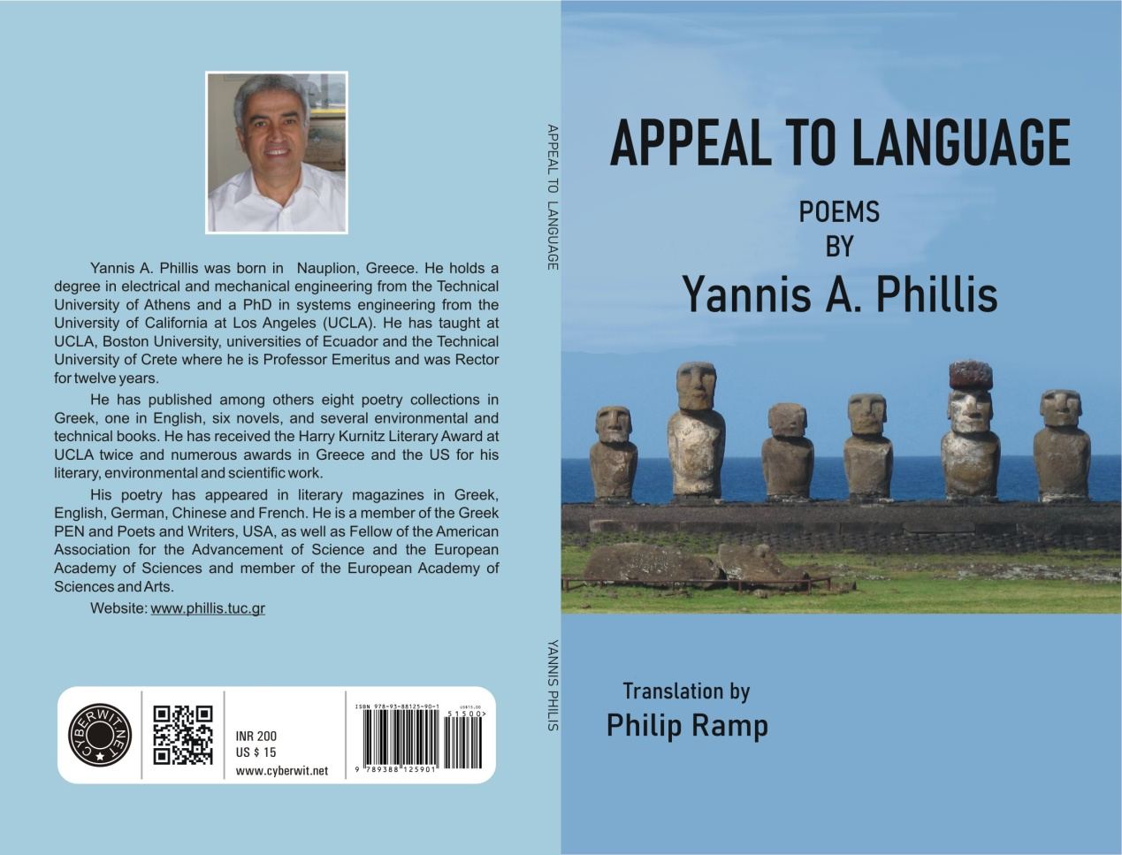

Appeal to Language Poems by Yannis Phillis

Hearty congratulations, Yannis, for the reason that your poems of this collection have appeared in Poetry Salzburg Review & Contemporary Poetry Volume 3. We very much wish that you come up with many more stories to narrate. Reading your book on poems was actually like reading stories. I found your writing very unique because of this.

Your love for rain is evident as I read and loved your lines “Where are the rainy nights that cleanse the face and return it to you in the morning eager by a new adjective to be graced” and your description on that night so vivid that the entire scene was before my eyes as in Rain in Athens. In Communication, “The rain is transforming the city into a metaphor as the drops tap out on the polished streets their own code, one which no one will get but the rain persists for the sake of one lonely bitter orange tree on the sidewalk which will shamelessly represent the world the moment everyone has fled”. This is something awesome I felt. Left me dumbstruck with your unique idea of rain communicating with Athens!!!

“How many voices, how much laughter, how many rituals does it take to nullify this void, how many trials and errors were required to settle me here on this speck of dust in one of billions of galaxies”. These lines seem straight from your heart as you reminisce your time with your family and that you are all alone in that same old place cutting bread, as in Time.

As your travels from Corinth to Athens, you seem to speak to yourself in lines, “I am gazing at cypress trees through the window as they hasten past like a film out of sync bending to wind’s whim. For a moment, I feel they are bowing to us as we pass but know as well we are but a fleeting details in a landscape that converses solely with wind and rain”.

Memory of Things, “I have no idea what I was looking for that afternoon, My old friend for years unable to communicate, victim of a degenerative brain disease. He looked at me for a fleeting moment and then his gaze returned to his blank void. His memory free to travel in space. I caught a glimpse of the galaxies it was crossing the lack of anything written between”. I can relate with your emotions for your need and eagerness to communicate with your friend but you couldn’t. “Not even she ever learned how Antonis from Thessalonika struggling to return to his childhood one morning made his escape from human memory on a scheduled flight gone missing for thirty five years now” in Escape; these two poems were really very touching.

How you were in Tibet, the country of nameless ghosts, “Mountain peak and above it vultures drawing circules before settling onto the naked dead bodies the poor villagers had laid there for a sky burial…At passport control arrival without departure is not allowed”.

Yannis, you seem to be a nature lover which is clear from your creations as in Easter Island, Santiago, Chile, San Juan – Puerto Rico, August, Midday because you have been able to capture all the aspects of nature along with movements of people. Reading them was like treat to my eyes and it was something like watching a movie.

How staring at the small ink bottles and the pages left unwritten, and penning song lyrics, mathematical symbols, food recipes, directions of a young woman’s home, leaving the ink for your descendants because they are of no use to you is something very differently penned by you, which I liked.

“There were many walls those people pray before and those that divide people into races, walls we call home. There were also those with works of art, walls colored, white, empty, walls of camps or of prison, walls of educational institutions”. This was philosophical but so true. Don’t we live amidst the walls? Answer is yes; many walls like walls of Ego, walls of hatred, walls of pride, etc.

Appeal to Language, your curiosity to learn about words with no antonym, two things unequivocally, one or two things from their opposites, as you sum up your poem, “I want to say that the wrong language is the lack of language. I want to say that language is not a euphemism”.

In Prologue, I agree to your words, “And things are better understood if left unsaid, and poetry is the art of leaving things ineffable”, and in Stories of Greece,“The investigation of names is the beginning of education, Antisthenes, The first duty of the true leader is the restoration of names Confucius”.

Readers, I am sure will love to read your poems penned in Civil War I and II.

By then I learned that only through silence are the hardest stories told” as in Silence, and “Science tells us one day everything will end” are the best catch lines ever. So philosophical and yet so true!!!

This book are more like his memoirs he experienced through his life which include more of nature, philosophy and war. Different topics and different stories to narrate!!! Readers, you will love all of them.

Yannis, we wish that your book inspires many more Writers like me to write differently and travels far and wide and garners all the recognition and fame. We look forward to your next book, as well. I will be happy to write a review for that one too☺

All the best.

Shubhaangi Kundalkar

Author – Justaju-In Search of Life

